Why Church?
The early Christians determined from the outset of the church the importance of gathering together, both in the Temple and in their homes.

Acts 2:46 And they, continuing daily with one accord in the temple, and breaking bread from house to house, did eat their meat with gladness and singleness of heart, 47 Praising God, and having favour with all the people. And the Lord added to the church daily such as should be saved.

- They met at the Temple every day.
- They often met at one another's homes.
- This caused many to be saved and the church grew daily.

The Apostle Paul later wrote:

Heb 10:25 Not forsaking the assembling of ourselves together, as the manner of some is; but exhorting one another: and so much the more, as ye see the day approaching.

Preaching happens at Church

The more church you attend, the more preaching and teaching you will hear.

From the birth of the church at Pentecost up until today, the preaching of the Word of God is what has always changed people's hearts.

Preaching may seem like a foolish thing to some, but it is the method that God chose to save mankind.

1 Cor 1:21 For after that in the wisdom of God the world by wisdom knew not God, it pleased God by the foolishness of preaching to save them that believe.

The more preaching you hear, the more faith you will have.

Rom 10:14 How then shall they call on him in whom they have not believed? And how shall they believe in him of whom they have not heard? And how shall they hear without a preacher? 15 And how shall they preach, except they be sent? as it is written, How beautiful are the feet of them that preach the gospel of peace, and bring glad tidings of good things! 17 So then faith cometh by hearing, and hearing by the word of God.

The more faith you have the more confidence you will have in your walk with God!

Joshua 1:8 This book of the law shall not depart out of thy mouth; but thou shalt meditate therein day and night, that thou mayest observe to do according to all that is written therein: for then thou shalt make thy way prosperous, and then thou shalt have good success.

Fellowship happens at Church

Acts 2:42 And they continued stedfastly in the apostles' doctrine and fellowship....

The Greek word for fellowship is "koinonia"; it means to be joined together in partnership.

Acts 2:44 And all that believed were together....

In a word, fellowship is togetherness.

- Together in Christ.
- Together in mind.
- Together in spirit.
- Together in effort.

Fellowship with other believers is an important part of our Christian walk.

Our Fellowship first begins in Christ, but it continues with one another

1 John 1:6 If we say that we have fellowship with him, and walk in darkness, we lie, and do not the truth: 7 But if we walk in the light, as he is in the light, we have fellowship one with another, and the blood of Jesus Christ his Son cleanseth us from all sin.

Breaking of Bread

It is one thing for Christians to fellowship in the church setting, but fellowship must also take place outside of the church also

Acts 2:46 And they, continuing daily with one accord in the temple, and breaking bread from house to house....

- The early church met in the Temple and also in one another's homes to fellowship and break bread together.

There is a spiritual and social aspect to fellowship. We need both.

- Our spiritual walk is strengthened when we fellowship with other believers.
- God filled us with a need for interaction with others.

It is not good to attempt to live for God without the fellowship of other Christians.

Gen 2:18 And the Lord God said, It is not good that the man should be alone; I will make him an help meet for him.

This need is both physical and spiritual.

- Nobody in the church should be an island to themselves
- We must get together with other believers not only in church but also outside the church in other settings.
  - Socialize with one another.
  - Become friends with one another.
  - Break bread together. (eat meals)

Once we are 'born again' into Christ we become a member of the family of Christ.

1 Cor 12:13 For by one Spirit are we all baptized into one body, whether we be Jews or Gentiles, whether we be bond or free; and have been all made to drink into one Spirit.

One of the aspects of the early church that caused rapid growth was the sharing of testimonies in one another's homes.

- We should also share the Word together.
- We should bear one another's burdens in prayer.
- We should also witness together.
  - Invite those who need to hear the Gospel to your home.

The early Christian’s invited their friends to both their church and their homes to tell them what God was doing for them.

Your friends and family will often times come to your home before they come to your Church.

Your Church Logo Here.

Your Church Web Address Here

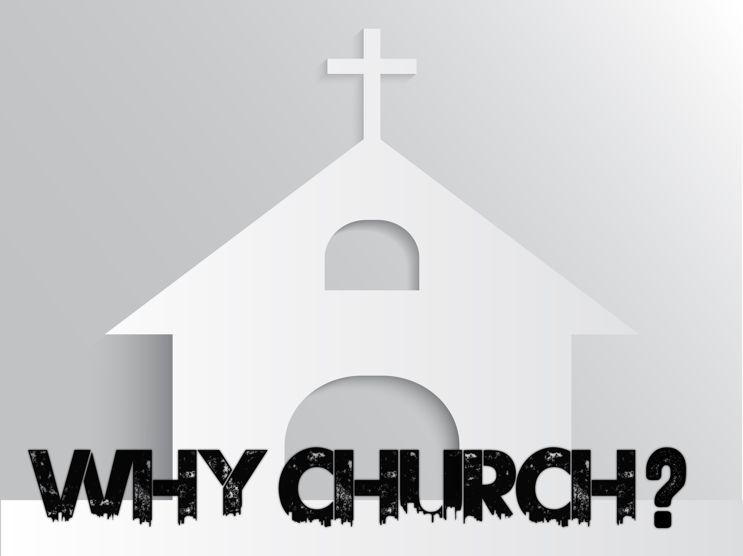

Those who regularly attend church are encouraged and their lives are changed as they position themselves to be ministered to by the Word of God, by experiencing His presence and by the fellowship of other believers.

